WEEK 2 – POWER BI DATA ANALYSIS
Superstore Sales & Profit Analysis Dashboard

INTRODUCTION
Microsoft Power BI is a powerful business intelligence tool used to analyze data and present information through interactive visualizations. This project focuses on analyzing the Superstore Sales Dataset to understand sales performance, profitability, customer orders, and regional business activities.

The dataset is processed and organized using Power Query and data modeling techniques. DAX (Data Analysis Expressions) is used to calculate key performance indicators such as Total Sales, Total Profit, Total Orders, Total Quantity, Average Sales, and Profit Margin.

Different visualizations, including KPI cards, column charts, line charts, slicers, and a decomposition tree, are used to develop an interactive dashboard. This project helps transform raw sales data into meaningful information that can be used for business analysis and decision-making.

OBJECTIVES
The main objectives of this project are:

- To explore and analyze the Superstore Sales Dataset using Power BI.
- To clean, prepare, and organize the dataset for analysis.
- To create a structured data model using tables and relationships.
- To develop DAX measures for calculating business performance metrics.
- To examine sales and profit across product categories and regions.
- To visualize sales trends over time.
- To design an interactive dashboard with filtering options.
- To identify useful patterns and insights from the sales data.

DATASET DESCRIPTION
The Superstore Sales Dataset is a business dataset that contains information about customer transactions, products, sales, profits, and geographical regions.

It is used to study different aspects of business performance, including product sales, customer segments, order quantities, and changes in sales over time.

Important Columns

Column Name | Description
Order Date | Date when the customer placed an order

Ship Date | Date when the order was shipped
Customer ID | Unique customer identification
Customer Name | Name of the customer
Product ID | Unique product identification
Product Name | Name of the product
Category | Main product category
Sub-Category | Specific product group
Sales | Revenue generated from sales
Quantity | Number of products ordered
Profit | Profit or loss from transactions
Region | Geographical sales region
Segment | Customer classification

DATA PREPARATION
The Superstore Sales Dataset was imported into Power BI for processing and analysis. The dataset was examined to understand its structure and identify the fields required for dashboard development.

Power Query was used to organize the data and verify the data types of important columns. Date fields were prepared for time-based analysis, while sales, profit, and quantity fields were used for numerical calculations.

A separate Date Table was created to support time-based analysis. Customer, Product, and Region tables were also organized as part of the data model. Relationships were established between the relevant tables to enable proper filtering and analysis.

The prepared dataset was then used to create DAX measures and build the final dashboard.
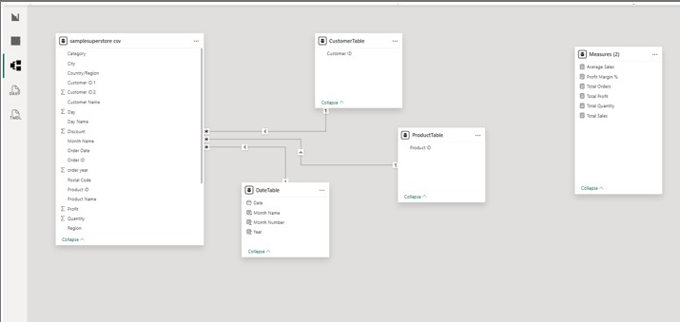

DATE TABLE CREATION

A separate Date Table was created in Power BI to support time-based analysis and organize date information.

The table contains the following columns:

- Date
- Year
- Month Name
- Month Number

The Date Table was connected to the Order Date column in the Superstore dataset. This relationship enables the dashboard to display sales information across different years and months.

The Month Number column can also be used to arrange month names in chronological order, making the sales trend chart easier to understand
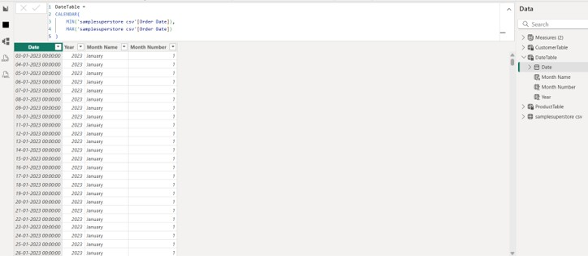

DAX MEASURES
DAX stands for Data Analysis Expressions. It is used in Power BI to perform calculations and create measures that summarize business data.

The following measures were created to analyze the Superstore dataset.

Measure | Purpose
Total Sales | Calculates the overall sales amount
Total Profit | Calculates the total profit earned
Total Orders | Counts the number of orders
Total Quantity | Calculates the total quantity sold
Average Sales | Calculates the average sales value
Profit Margin % | Calculates profit as a percentage of sales

These measures are displayed using KPI cards and are also used in the dashboard visualizations to support interactive analysis.

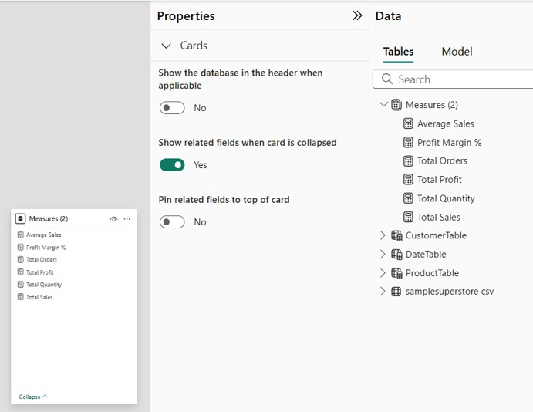

DASHBOARD COMPONENTS
The Superstore Sales and Profit Analysis Dashboard was developed using different Power BI visualizations. Each component provides a different view of the dataset and helps users explore business performance.

KPI Cards

Six KPI cards were designed to display important business metrics:

    - Total Sales
    - Total Profit
    - Total Orders
    - Total Quantity
    - Average Sales
    - Profit Margin %

These cards provide a quick summary of the selected data.

Category-wise Sales Analysis

A clustered column chart was created to compare sales across product categories.

This visualization helps users examine how sales are distributed among different categories and compare their contribution to overall sales.

Region-wise Profit Analysis

A clustered column chart was used to display profit across different geographical regions.

This chart allows users to compare regional profitability and identify variations in profit performance.

Sales Trend Analysis

A line chart was created to display sales over time using the Date Table.

It helps users observe changes in sales across different dates and identify possible trends or fluctuations.

Interactive Slicers

Slicers were added to make the dashboard interactive. The dashboard includes filters for:
    - Year
    - Category
    - Region
    - Segment

Users can select different values to view specific portions of the dataset.

Decomposition Tree

A decomposition tree was included to explore the breakdown of Total Sales by Category.

It allows users to expand the data into different categories and investigate how sales are distributed across the selected dimensions.

DASHBOARD DESIGN
The final dashboard combines KPI cards, charts, slicers, and a decomposition tree into a single interactive report.

The layout is designed to present important business information in a clear and organized manner. Users can view overall performance through KPI cards and explore detailed information using charts and filters.

The dashboard provides different perspectives of sales and profit performance, making it easier to examine the dataset without manually reviewing individual records.

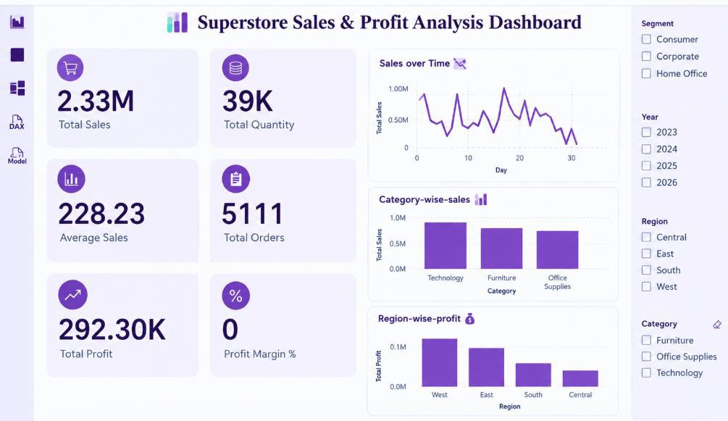

KEY INSIGHTS
The dashboard provides the following types of business insights:

- Overall Sales Performance: KPI cards summarize sales, profit, orders, and quantity for the selected data.

- Profitability Analysis: Total Profit and Profit Margin % provide information about business profitability.

- Product Category Analysis: Category-wise sales visualization helps compare the sales contribution of different product categories.

- Regional Performance: Region-wise profit analysis highlights differences in profit across geographical regions.

- Sales Trends: The line chart helps users examine sales movements over time.

- Customer Segment Analysis: Segment slicers allow users to explore sales performance for different customer groups.

- Detailed Sales Breakdown: The decomposition tree provides a way to investigate sales across different categories.

ADVANTAGES
- Interactive Dashboard: Users can explore the dataset through filters and visualizations.

- Clear Data Presentation: Charts and KPI cards simplify the understanding of business information.

- Comparative Analysis: Sales and profit can be compared across categories and regions.

- Time-Based Analysis: The Date Table supports analysis across different dates and years.

- Flexible Filtering: Slicers help users focus on selected categories, regions, years, and customer segments.

- Efficient Reporting: Multiple business metrics are presented in one dashboard for convenient analysis.

CONCLUSION
The Superstore Sales and Profit Analysis project was developed using Microsoft Power BI to explore and visualize business sales data. The dataset was prepared and organized, and a structured data model was created using relevant tables and relationships.

DAX measures were used to calculate important business metrics, including Total Sales, Total Profit, Total Orders, Total Quantity, Average Sales, and Profit Margin. Various visualizations were combined to develop an interactive dashboard.

The completed dashboard enables users to examine sales performance, compare product categories, analyze regional profit, and explore sales trends over time. Overall, this project demonstrates the use of Power BI for data preparation, data modeling, business analysis, and interactive data visualization.

TOOLS AND TECHNOLOGIES

Component | Technology Used
Business Intelligence Tool | Microsoft Power BI
Data Preparation | Power Query
Data Modeling | Tables and Relationships
Calculations | DAX
Data Visualization | KPI Cards, Column Charts, Line Chart
Interactive Analysis | Slicers and Decomposition Tree
Dataset Used: Superstore Sales Dataset

